**Assignment weeks 6, 7 and 8**

*To answer all the questions below, you must use Stata (and, specifically, DASP, if requested). Be concise and clear in your answers.*

*The assignment is divided into three exercises (the points assigned to each exercise are indicated next to each exercise). Please answer (A) directly in this file after each question (Q) and please attach the *.do file (do-file) that you generated. Rename both files as: “Assignment weeks 6_7_8 - Name, Surname”. Please submit this completed file and the *.do through the virtual drop box (boîte de dépôt) in the course portal, no later than Tuesday, March 23 11:59 p.m. (*[***Québec time***](https://www.timeanddate.com/worldclock/converter.html?iso=20190327T035900&p1=189)*).*

# Exercise 1 (3.5%):

1. Using the data file data_b3_3.dta, estimate the subjective poverty line, by considering the following information:

* The observed equivalent-adult wellbeing is the variable: *ae_exp*
* The perceived minimum equivalent-adult wellbeing to escape poverty is *min_ae_exp.*
* The individual is the unit of analysis (use the household size variable).

**A :**

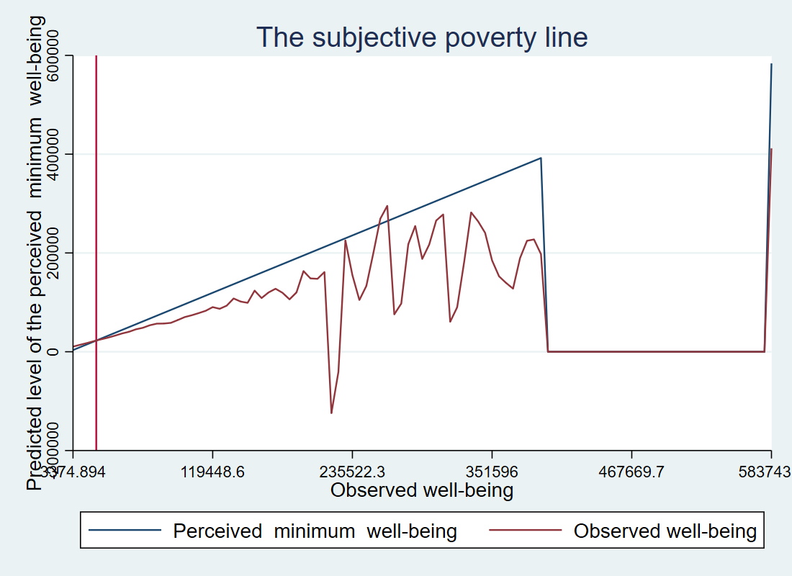

1.2 Estimate the poverty gap (using the variables: *ae_exp* and *hsize*) for each of the three cases, and then discuss the results:

1. the subjective poverty line;
2. the absolute poverty line (z=20900)
3. The relative poverty line: (z= half of average income).

**A : Check result in do file**

1.3 In your opinion, which is the most appropriate method for measuring poverty in developed countries and why?

**A : Developed countries should use the relative approach since its easy to establish the cutting points for set of good and services received per person.**

# Exercise 2 (4.5%):

Additive poverty indices, like the FGT index, allow performing an exact analytical decomposition of these indices by population subgroups. This is useful to show the contribution of each group to total poverty.

2.1 Use the file data_b3_3.dta and decompose poverty (headcount index) by the gender of the household head (***sex***) (the poverty line is 20900). What can we conclude?

**A : The contribution of poverty among households headed by women is greater than the contribution that comes from their representativeness in the total population (0.45 VS 0.25)**

2.2 Estimate the total poverty (headcount) according to the region of the household head (***region***).

**A :**

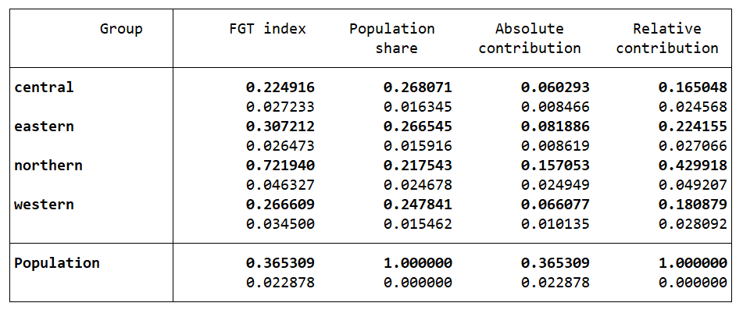

2.3 The distribution of the adult equivalent expenditures is similar to that of the initial period (*ae_exp*), with the following slight differences

* the adult equivalent expenditures have increased by 11% in region 3;
* the adult equivalent expenditures have decreased by 6% in region 2;

Generate the variable *ae_exp2,* based on the information above.

**A : Check result in do file**

2.4 By using the Shapley approach, decompose the poverty gap change into growth and redistribution. Discuss the results.

**A : Check result in do file.**

**Using Shapley approach the growth estimate is 0.001021, and redistribution is**

**-0.003068 lower than the rest.**

2.5 Perform a sectoral decomposition (based on region groups) of the change in total poverty gap. Discuss the results.

**A : Check result in do file**

# Exercise 3 (4.5%):

Assume that the population is composed of ten individuals. The following table shows the distribution of incomes of two successive periods.

|  |  |  |  |
| --- | --- | --- | --- |
| *Identifier* | *weight* | *inc_t1* | *Inc_t2* |
| 0 | 0 | 0.00 | 0.00 |
| 1 | 0.1 | 1.50 | 1.54 |
| 2 | 0.1 | 4.50 | 3.85 |
| 3 | 0.1 | 7.50 | 6.60 |
| 4 | 0.1 | 3.00 | 2.75 |
| 5 | 0.1 | 4.50 | 4.40 |
| 6 | 0.1 | 9.00 | 7.70 |
| 7 | 0.1 | 10.50 | 8.80 |
| 8 | 0.1 | 15.00 | 7.70 |
| 9 | 0.1 | 12.00 | 6.60 |
| 10 | 0.1 | 13.50 | 6.60 |

3.1 Insert the data, and then generate the percentiles (*based on the rank of incomes of the initial period (variable perc)), and the first percentile must be equal to zero*).

**A : Check result in do file.**

3.2 Initialize the scalar *g_mean*, which is equal to the growth rate in the average income.

**A : Check result in do file.**

3.3 Generate the variable *g_inc*, as the growth in individual incomes.

**A : Check result in do file.**

3.4 Draw the *Growth Incidence Curve* using the variables *g_inc* and *perc*. Discuss the results.

**A :**

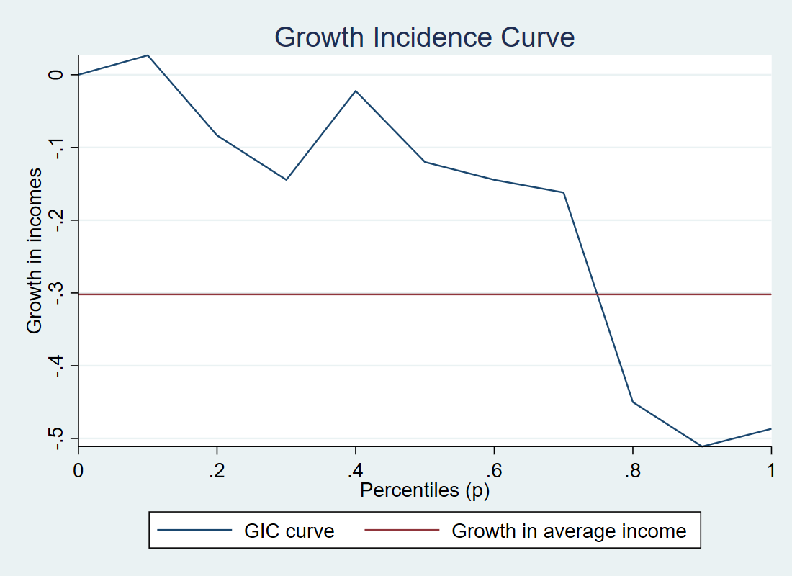

3.5 Assume that the poverty line is equal to 10.4. Estimate the Chen and Ravallion (2003) pro-poor index ($IP=\frac{1}{q}\sum_{i=1}^{q}{γ^{t}\left(p_{i}\right)}$). Discuss the results.

**A : Check result in do file.**

3.6 Using the Shapley approach decompose the change in the poverty gap into growth and redistribution components. Discuss the results.

**A : Check result in do file.**